COOPERATIVE HERITAGE • MEMBER EDUCATION

From £28 to One Billion People:

The Cooperative Story That Shapes GTCS Today

In the winter of 1844, twenty-eight weavers and artisans in a mill town in northern England did something that would quietly reshape the global economy. They did not have venture capital. They did not have government backing. They had £28 — one pound each — and a conviction that ordinary people, working together, could build something that served them rather than exploited them.
That conviction became the Rochdale Society of Equitable Pioneers — the world’s first successful modern cooperative. And the principles those twenty-eight workers hammered out in a small store on Toad Lane are the same principles that undergird GTCS today.

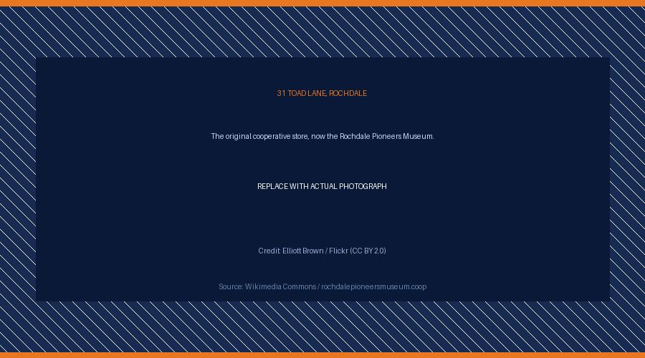
31 Toad Lane, Rochdale — the birthplace of the modern cooperative movement, now the Rochdale Pioneers Museum. Photo credit: Elliott Brown / Flickr (CC BY 2.0) — commons.wikimedia.org
“The strongest cooperative story is not simply ‘the first cooperative in the world’ but ‘the first successful modern cooperative that became the model for over a billion cooperative members worldwide.’”

England, 1844: The Problem That Started It All
To understand why the Rochdale Pioneers matter, you need to understand the world they lived in. Industrial England in the 1840s was a place of sharp contrasts. Factories were producing wealth on a scale never seen before — but that wealth was not reaching the people who produced it.
Working-class families faced three interlocking crises. Food was expensive and routinely adulterated — millers mixed chalk into flour, grocers watered down milk, and merchants sold short weights without consequence. Wages were low and irregular, controlled entirely by factory owners. And credit, when it was available to the poor at all, came with punishing interest that kept families in permanent debt.
The Rochdale Pioneers — most of them weavers and flannel workers — had tried other approaches. They had gone on strike. They had petitioned Parliament. They had joined trade unions. None of it had produced lasting change. Then, drawing on the earlier cooperative ideas of Robert Owen and others, they decided to try something different: to build their own economy.

THE FOUNDING FACTS
Rochdale Society of Equitable Pioneers
- Founded: 21 December 1844, Rochdale, Lancashire, England
- Founders: 28 working-class artisans and weavers
- Starting capital: £28 (each member contributed £1)
- First products: flour, sugar, butter, oatmeal, candles
- Location: 31 Toad Lane, Rochdale (now a museum open to visitors)

What Made Them Different: The Rochdale Principles
Cooperative-style arrangements had existed before 1844. What the Rochdale Pioneers did differently was codify their model into a set of written principles — and then stick to them. That discipline is what turned a small grocery store into the foundation of a global movement.

One member, one vote
Every member had an equal say in how the cooperative was run, regardless of how much they had invested. This was radical in an era when economic power translated directly into political power. At Rochdale, a weaver who had saved £1 had the same vote as a founding committee member.

Open and voluntary membership
Any person who agreed to the cooperative’s rules could join. There was no exclusion based on occupation, religion, or social standing. The cooperative existed to serve its members, not to gatekeep access.
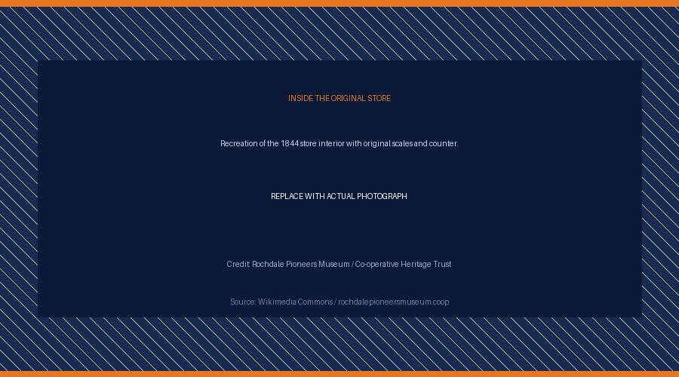
Inside the Rochdale Pioneers Museum — a faithful recreation of the original 1844 store with its rudimentary counter, scales, and first stock. Photo credit: Rochdale Pioneers Museum / Co-operative Heritage Trust — rochdalepioneersmuseum.coop

Profit sharing among members
Surplus was returned to members in proportion to what they had spent at the store — not distributed to external shareholders. This was the Rochdale ‘divi’ (dividend), and it gave ordinary families their first taste of what it felt like to own a share of a commercial enterprise that worked in their favour.

Education, training, and information
The Pioneers set aside a portion of their surplus specifically for member education. This was not philanthropy — it was strategy. They understood that an informed member was a better member, and that the cooperative would only remain true to its values if its members understood those values.

Cooperation among cooperatives
The Rochdale model was never meant to stay in Rochdale. The Pioneers envisioned a network of cooperatives that would trade with, support, and strengthen one another. That vision eventually produced the International Co-operative Alliance, founded in 1895, which now represents over three million cooperatives worldwide.

How One Store Became a Global Movement
The Rochdale store opened on 21 December 1844 with modest stock and grand ambitions. In the first year, membership grew from 28 to 74. By 1850 there were 600 members. By 1900 the cooperative model had spread across Britain, Europe, North America, and beyond.
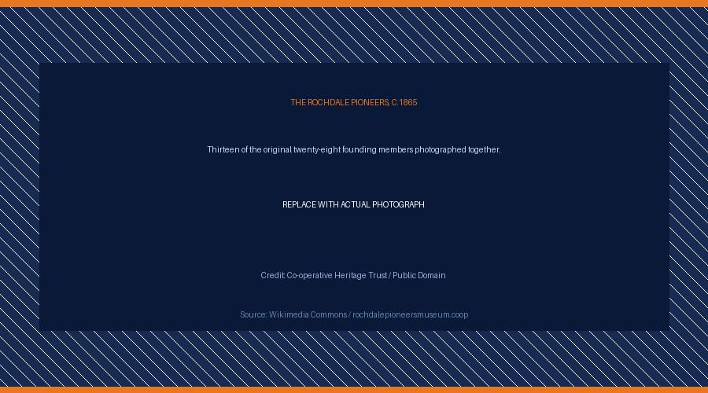
Thirteen of the original twenty-eight founding members of the Rochdale Equitable Pioneers Society, photographed together circa 1865. Image credit: Co-operative Heritage Trust / Public Domain — co-operativeheritage.coop
What travelled with it were the principles. Every agricultural cooperative that helped a West African farmer get fair value for cocoa. Every credit union that gave a Nigerian family access to savings. Every housing cooperative that let working families own their home. Every consumer cooperative that returned surplus to shoppers rather than to shareholders. All of them trace their intellectual lineage back to Toad Lane.
The numbers today are staggering. More than one billion people worldwide are cooperative members. Cooperatives operate in over 100 countries. The largest cooperative economies — France, Germany, the Netherlands — are home to cooperatives that rank among the biggest enterprises in their sectors. In Nigeria alone, the cooperative movement employs millions and channels billions of naira through member-owned savings and credit societies every year.
“From one small store in 1844, the cooperative model spread across the world. Today it serves more than one billion people in over 100 countries.”
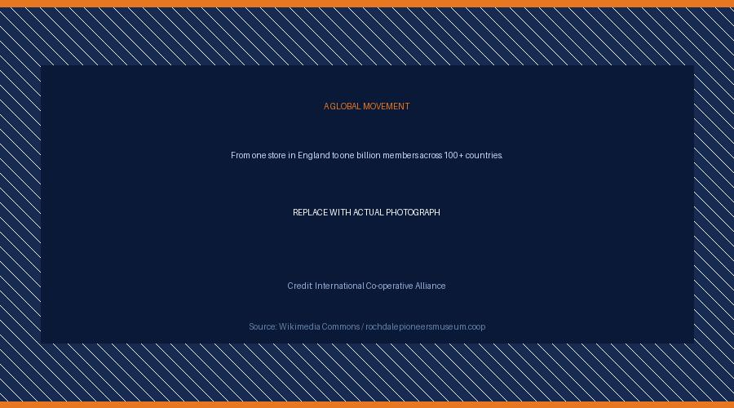
The global reach of the cooperative movement — active in over 100 countries, serving more than one billion members worldwide. Illustration: International Co-operative Alliance / ica.coop

Why This Matters to Every GTCS Member
The Rochdale Pioneers were not financiers. They were not entrepreneurs in the conventional sense. They were ordinary workers who looked at a system that was failing them and built a better one.
That is the same impulse that drives GTCS. Every member who contributes to our thrift, accesses cooperative credit, or participates in our governance is continuing a tradition that is 180 years old and has proven itself on every continent. When you join GTCS, you are not joining a new experiment. You are joining the most tested financial model in human history.
The economic pressures our members face today — rising costs of living, limited access to fair credit, the need for reliable savings mechanisms — are not so different from what those twenty-eight weavers faced in 1844. And the solution they found is not so different from what GTCS offers: member ownership, democratic control, and the conviction that ordinary people, working together, are stronger than any of them working alone.

The Heritage We Carry Forward
It is worth pausing to appreciate what 180 years means. Empires have risen and fallen in that time. Financial systems have collapsed. Companies that once seemed unshakeable have disappeared entirely. And yet the cooperative model — built on mutual accountability, democratic participation, and shared benefit — has not only survived but grown.
That durability is not accidental. It is the direct result of the principles the Rochdale Pioneers built in from the beginning. Principles that put people before profit. That demanded transparency from leadership. That returned value to the people who created it rather than to distant investors. That treated education as a core function, not an afterthought.
At GTCS, we are custodians of that heritage. Our constitution, our governance, our thrift and credit operations — all of it reflects principles that were first articulated in a small mill town in England by people who had every reason to give up and chose instead to build.
We carry that work forward. And we invite every member to carry it with us.

THE GLOBAL LEGACY IN NUMBERS
- 1844 — Year the first successful modern cooperative was founded
- 28 — Founding members of the Rochdale Pioneers
- £28 — Starting capital (one pound per member)
- 180+ — Years of proven cooperative model
- 100+ — Countries with active cooperative economies
- 1 billion+ — Cooperative members worldwide

DEVELOPER GUIDE

How to Host This Blog on Your Website
This guide covers everything a developer needs to publish and maintain the GTCS cooperative heritage blog post — from choosing a platform to managing photo credits and SEO. It is written for someone comfortable with basic web hosting but who may not have built a blog before.

Step 1: Choose Your Blogging Platform
The right platform depends on whether GTCS already has a website and how much technical control you want. The three most practical options for a cooperative of this size are:

Option A — WordPress (self-hosted)
WordPress powers over 40% of all websites globally and is the gold standard for organisational blogs. You install it on your own hosting account, giving you full control over design, data, and future functionality.
- Best for: organisations that want ownership and flexibility
- Hosting cost: £5–10/month on Bluehost, SiteGround, or Namecheap
- Technical requirement: basic FTP/cPanel familiarity

Option B — Ghost (self-hosted or managed)
Ghost is a modern, focused publishing platform built for professional blog content. It is faster than WordPress and has cleaner default design, but fewer plugins.
- Best for: clean editorial design with minimal setup
- Managed hosting: from $9/month at Ghost.io
- Technical requirement: Node.js server for self-hosting

Option C — Static site (Hugo or Eleventy) with Netlify
If GTCS has a developer comfortable with the command line, a static site generator produces the fastest, most secure, and lowest-cost blog possible. Content is written in Markdown and compiled to HTML.
- Best for: developers who want maximum performance and zero hosting cost
- Hosting cost: £0 on Netlify or Cloudflare Pages
- Technical requirement: Git, Node.js, and CLI familiarity

Component | Recommended Option | Notes
Platform | WordPress | Best balance of flexibility and ease for a cooperative organisation
Hosting | SiteGround / Namecheap | Reliable UK/Nigeria-accessible providers with good support
Theme | Kadence or Astra | Free, fast, accessible, and fully customisable to GTCS brand colours
Domain | gtcs.coop or gtcsnigeria.org | Register via Namecheap or 101domain; .coop TLD signals cooperative identity
CDN | Cloudflare (free) | Speeds up delivery in Nigeria; adds DDoS protection
SSL | Let's Encrypt (free) | Required for Google ranking; most hosts install this automatically

Step 2: Structuring the Article in Your CMS
When you paste this article into WordPress, Ghost, or any CMS, apply the following structure consistently. This ensures correct rendering and good SEO.

Post metadata
- Title: From £28 to One Billion People: The Cooperative Story That Shapes GTCS Today
- Slug: gtcs-cooperative-history-rochdale-pioneers
- Category: Member Education / Cooperative Heritage
- Tags: cooperative history, Rochdale Pioneers, GTCS, thrift and credit, cooperative principles
- Author: GTCS Editorial Team

SEO meta description (160 characters max)
Discover how 28 workers with £28 in 1844 built the cooperative model now serving 1 billion people — and why it matters to every GTCS member today.

Open Graph image
Upload the GTCS infographic PNG (delivered alongside this document) as the featured image / Open Graph image. It will display when the post is shared on WhatsApp, Facebook, or Twitter/X. Recommended size: 1200 × 630px. The infographic is already at the right ratio; resize with any image editor if needed.

Step 3: Sourcing and Crediting Photographs
All historical photographs of the Rochdale Pioneers and Toad Lane are in the public domain or available under Creative Commons licences. Use the sources below. Never publish an image without a visible credit line — both for legal compliance and to model the transparency values that cooperatives are built on.

Component | Recommended Option | Notes
Toad Lane exterior | Elliott Brown / Flickr | CC BY 2.0 — search Flickr for ‘Toad Lane Rochdale’; download and credit in caption
Store interior | Rochdale Pioneers Museum | Contact rochdalepioneersmuseum.coop for press images; free for editorial use
Pioneers group photo | Co-operative Heritage Trust | Public domain — available at co-operativeheritage.coop
Historic maps/prints | Wikimedia Commons | Filter by CC BY or Public Domain at commons.wikimedia.org
Modern coop photos | ICA Photo Library | Free for media use; credit: International Co-operative Alliance / ica.coop
Nigeria cooperative | FAO / Flickr | CC BY-NC-SA 2.0 — search Flickr for ‘Nigeria cooperative’

Caption format to use on every image
[Descriptive sentence about what the image shows]. Photo credit: [Photographer Name] / [Source] ([Licence])

Example:
31 Toad Lane, Rochdale — the original 1844 cooperative store, now the Rochdale Pioneers Museum. Photo credit: Elliott Brown / Flickr (CC BY 2.0).

Step 4: Performance and SEO Checklist
A blog post that does not load quickly or cannot be found by search engines has limited reach. Run through this checklist before publishing.

Images
- Compress all images to under 200KB using Squoosh (squoosh.app) or TinyPNG
- Save in WebP format where your CMS supports it (30–40% smaller than JPEG)
- Add descriptive alt text to every image (important for accessibility and SEO)
alt="31 Toad Lane Rochdale, the original Rochdale Pioneers cooperative store opened in 1844"

Content SEO
- Include the primary keyword ‘cooperative history Nigeria’ or ‘Rochdale Pioneers’ naturally in the first 100 words
- Use one H1 (the post title), H2 for main sections, H3 for sub-points. Never skip levels.
- Internal link to GTCS membership page, thrift account page, and any related blog posts
- External link to the Rochdale Pioneers Museum (rochdalepioneersmuseum.coop) and ICA (ica.coop) for credibility signals

Technical
- Enable Cloudflare on your domain (free tier) for CDN delivery across Nigeria
- Install Yoast SEO (WordPress) or use Ghost’s built-in SEO fields
- Submit the post URL to Google Search Console after publishing
- Test mobile rendering on a real Android device — majority of Nigerian readers are on mobile
- Run Google PageSpeed Insights; aim for a score above 80 on mobile

Step 5: Distribution After Publishing
Publishing the post is the beginning, not the end. Use the following channels to extend reach within the GTCS membership and beyond.

Component | Recommended Option | Notes
WhatsApp | Broadcast list + groups | Share the post link with a one-line teaser. WhatsApp is the primary content channel in Nigeria.
Facebook | GTCS page post + member groups | Post the infographic as the image; include link in caption. Boost post for ₣1,000–2,000 for wider reach.
Email newsletter | Mailchimp (free to 500 contacts) | Send a short email: two-sentence summary + Read More button linking to the post.
Instagram | Carousel using infographic panels | Split the infographic into three square panels for a swipe-through carousel post.
Twitter / X | Thread format | Break the key facts into a 6–8 tweet thread; link to full post in the last tweet.
Print | A4 or A5 handout | Print the DOCX for distribution at GTCS meetings, AGMs, or member induction sessions.

Published by GTCS — God’s Treasury Cooperative, Thrift and Credit Society
Member Education Series | Cooperative Heritage | Developer Guide v1.0

